# Guidance on writing accessible documents

Nov 2024, V1.0

A core principle for involvement is that people who are affected by a service change are fully informed, in order to make a decision about the change they may be affected by. Making sure documents are as accessible as they can be is a key factor in allowing as many people as possible to be involved. If a document meets people’s needs, they are better equipped to take part.

In this guidance, there are some key top tips to make documents as accessible as possible. To meet people’s needs, we should write all our documents with the following in mind.

* **Plain English** – the average national reading age of the country is nine years old. That means we should be writing any public facing documents as though we need it to be understood by a nine-year-old.
* **Web Content Accessibility Guidelines** - all public organisations (such as the NHS and any commissioned by the NHS services) are required to follow the Web Accessibility requirements which outlines requirements for any content and documents that are published online: <https://www.gov.uk/service-manual/helping-people-to-use-your-service/understanding-wcag>. It takes into consideration the accessibility of documents viewed on a computer screen (for people using assistive tools, such as screen readers).
* **Designed documents** – if you get a document designed using a graphic designer, it is likely that the documents are not accessible, in these cases a ‘plain-text’ version of the document should accompany any designed document, you can see an example on the Leeds Health and Care Partnership’s website: <https://www.healthandcareleeds.org/publications/involving-you-2021-2022/>

You can find other useful tools and links to related documents on our Leeds Health and Care Partnership Website here: <https://www.healthandcareleeds.org/have-your-say/get-involved/involvement-support/>

## Top tips (non-accessible version)

This section demonstrates, where possible, how things should (or shouldn’t) look. A [plain text](#_Top_tips_(plain-text) version is below.

If the document we want to upload to the website is accessible then we do not need to plain-text it as standard. It can be offered as an alternative format on request.

If the document isn’t accessible, it needs a plain-text version to accompany it. Given the resource implication in time it takes to plain-text something, our approach should certainly be to make all documents as accessible as they possibly can be, this includes:

* Using **bold** sparingly, mainly in headings
* No *italics*
* No underlining (hyperlinks is fine)
* Correct use of hyperlinks:
  + If online only, can be hyperlinked in the words for what you’re referring to, such as [Leeds Health and Care Partnership](https://www.healthandcareleeds.org/)
  + If document could be in print, it needs to be written out, such as Leeds Health and Care Partnership website (<https://www.healthandcareleeds.org/>)
* We can use tables, but they need to be simple (not split or merge cells that may make it confusing for assistive technology)

### Simple table

|  |  |  |  |
| --- | --- | --- | --- |
|  |  |  |  |
|  |  |  |  |

* + If a particular cell in a table gets too long (like a lot of bullet points) we can use another row for the remaining text, repeat the information used previously and white out:
    - using white text colour and white line dividers, go to ‘Table properties > ‘Borders and shading’ and use ‘custom’, select white colour and the correct line to ‘white out’ to provide screen readers with the information needed but without making the aesthetic more confusing for readers.

### Managing a table if a cell is too long (highlight the text in the boxes and change the colour to see what’s there) – the table used is the same as above!

|  |  |  |  |
| --- | --- | --- | --- |
| Test (1 of 2) | Highlight the text | 2023 | There’s maybe too |
| Test (2 of 2) | Make the text black |  | much information |

* + Tables also need to have the headers at the top of each page, easily done in the ‘Table layout’ option at the top of the menu, using ‘repeat header row’.
* Images all need alt text (description of what the image is)
  + This includes header images / logos.
  + You can set alt text on images separately to a document, so they already have the alt text included when you include your image.
  + If the image is too text heavy / hard to describe to include in the alt text then an accompanying text version needs to be included (either directly underneath the image or as an Appendix, the image can also be the item that is appendixed).
    - You can use the ‘bookmark’ feature to link someone to said appendix item by clicking an internal link.
* Capitalisation
  + Should Generally Be Avoided, Even In Most Headings, Especially Mid-Sentence. Names are ok.
  + Don’t use ALL CAPS.
* Numbers
  + Numbers up to ten should be written verbatim (one, two, three) not numerically.
  + 11 and higher should be written numerically (11, 12, 13).
  + Exception to the above is when using for percentages (5%) or similar.

## We need to use headings.

* + That’s not the titles of a section in larger font and in bold but using the headings options in the ‘styles’ menu. These can be tailored to meet the design choices we need for our docs.
  + Headings allows us to use the ‘link to a place in this document’ using bookmarks. CTRL+K and then select ‘link to a place in this document and choose the heading you want it to go to).
  + Your title of the document should be ‘Heading 1’
  + Any headings for different sections of the document (background, top tips, themes etc.) should be ‘Heading 2’.
  + Any sub-sections / headings should be ‘Heading 3’.
  + Headings can be customised in the styles section under the ‘Home’ menu at the top (right click the heading / style you want and customise as needed).
* All font needs to be 12 point minimum (throughout)

### Other bits:

* + Using forward slash to indicate ‘or’ is fine but requires a space between each word and the forward slash, such as “and / or” not “and/or”.
  + Need to include page numbers, the footer should not have anything else in it.
  + Use page break if you want to start a new page, don’t keep pressing ‘Enter’ or ‘Return’ to get you to the next page – can be found in the ‘Insert’ option in the menus
  + Avoid footnotes1.
    - 1That’s these.
  + Be wary of colour, avoid bright / pale text on white backgrounds as they’re hard to read. If colour needs to be used make sure that they contrast.
  + Don’t use centre justified (even for titles)
  + Don’t                                      use                                                    fully                                        justified (left justified is fine).
  + 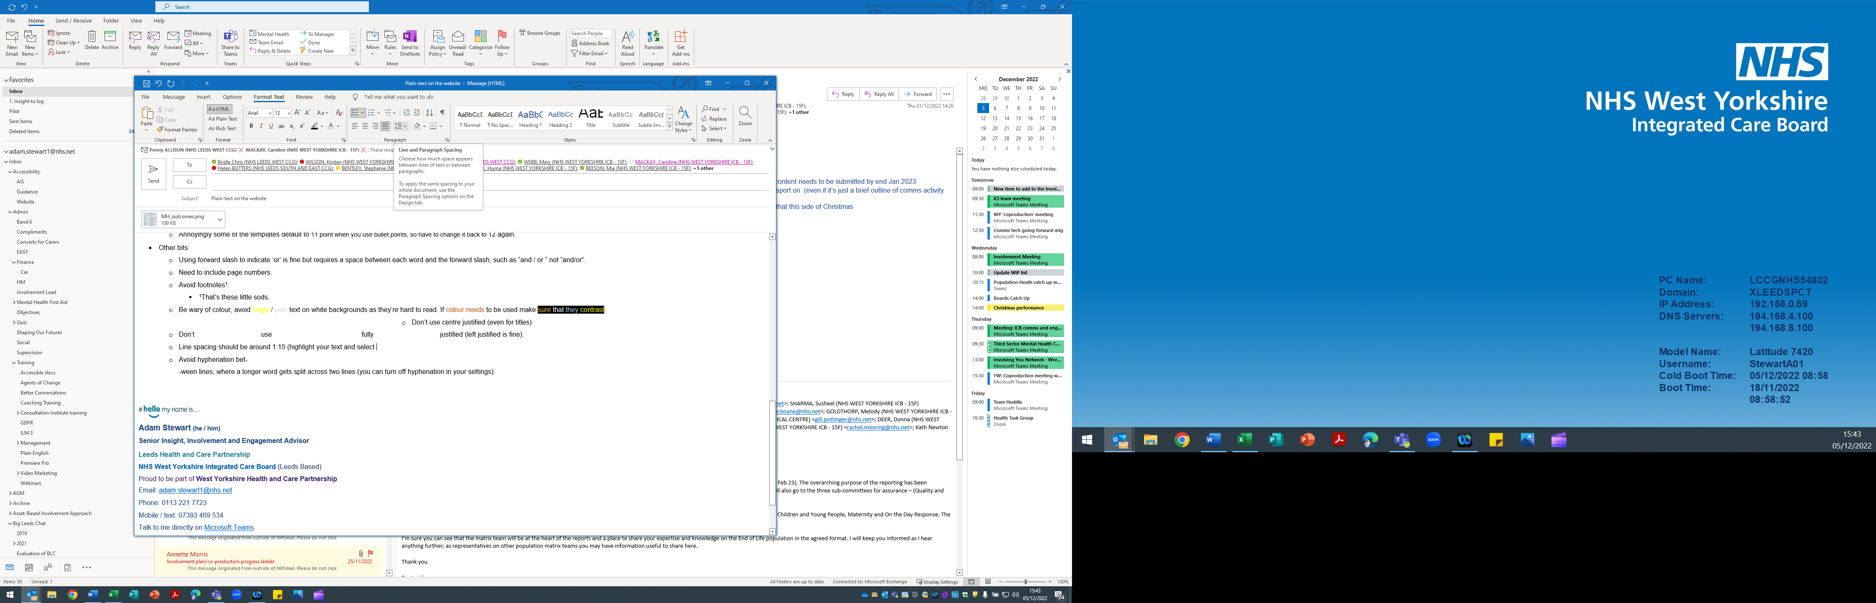Line spacing should be around 1.15 (highlight your text and select the line spacing button.
  + Avoid hyphenation bet-

-ween lines; where a longer word gets split across two lines (you can turn off hyphenation in your settings).

## Top tips (plain-text version)

This section demonstrates, where possible, how things should (or shouldn’t) look.

If the document we want to upload to the website is accessible then we do not need to plain-text it as standard. It can be offered as an alternative format on request.

If the document isn’t accessible, it needs a plain-text version to accompany it. Given the resource implication in time it takes to plain-text something, our approach should certainly be to make all documents as accessible as they possibly can be, this includes:

* Using bold sparingly, mainly in headings
* No italics
* No underlining (hyperlinks is fine)
* Correct use of hyperlinks:
  + If online only, can be hyperlinked in the words for what you’re referring to, such as [Leeds Health and Care Partnership](https://www.healthandcareleeds.org/)
  + If document could be in print, it needs to be written out, such as Leeds Health and Care Partnership website (<https://www.healthandcareleeds.org>)
* We can use tables, but they need to be simple (not split or merge cells that may make it confusing for assistive technology)
  + If a particular cell in a table gets too long (like a lot of bullet points) we can use another row for the remaining text, repeat the information used previously and white out:
    - using white text colour and white line dividers, go to ‘Table properties > ‘Borders and shading’ and use ‘custom’, select white colour and the correct line to ‘white out’ to provide screen readers with the information needed but without making the aesthetic more confusing for readers.
  + Tables also need to have the headers at the top of each page, easily done in the ‘Table layout’ option at the top of the menu, using ‘repeat header row’.
* Images all need alt text (description of what the image is)
  + This includes header images / logos.
  + You can set alt text on images separately to a document, so they already have the alt text included when you include your image.
  + If the image is too text heavy / hard to describe to include in the alt text then an accompanying text version needs to be included (either directly underneath the image or as an Appendix, the image can also be the item that is appendixed).
  + You can use the ‘bookmark’ feature to link someone to said appendix item by clicking an internal link.
* Capitalisation
  + Should generally be avoided, even in most headings, especially mid-sentence. Names are ok.
  + Don’t use ALL CAPS.
* Numbers
  + Numbers up to ten should be written verbatim (one, two, three) not numerically.
  + 11 and higher should be written numerically (11, 12, 13).
  + Exception to the above is when using for percentages (5%) or similar.
* We need to use headings.
  + That’s not the titles of a section in larger font and in bold but using the headings options in the ‘styles’ menu. These can be tailored to meet the design choices we need for our docs.
  + Headings allows us to use the ‘link to a place in this document’ using bookmarks. CTRL+K and then select ‘link to a place in this document and choose the heading you want it to go to).
  + Your title of the document should be ‘Heading 1’
  + Any headings for different sections of the document (background, top tips, themes etc.) should be ‘Heading 2’.
  + Any sub-sections / headings should be ‘Heading 3’.
  + Headings can be customised in the styles section under the ‘Home’ menu at the top (right click the heading / style you want and customise as needed).
* All font needs to be 12 point minimum (throughout).

### Other bits:

* Using forward slash to indicate ‘or’ is fine but requires a space between each word and the forward slash, such as “and / or” not “and/or”.
* Need to include page numbers, the footer should not have anything else in it.
* Use page break if you want to start a new page, don’t keep pressing ‘Enter’ or ‘Return’ to get you to the next page – can be found in the ‘Insert’ option in the menus
* Avoid footnotes.
* Be wary of colour, avoid bright / pale text on white backgrounds as they’re hard to read. If colour needs to be used make sure that they contrast.
* Don’t use centre justified (even for titles)
* Don’t use fully justified (left justified is fine).
* Line spacing should be around 1.15 (highlight your text and select the line spacing button.
* Avoid hyphenation between lines; where a longer word gets split across two lines (you can turn off hyphenation in your settings).